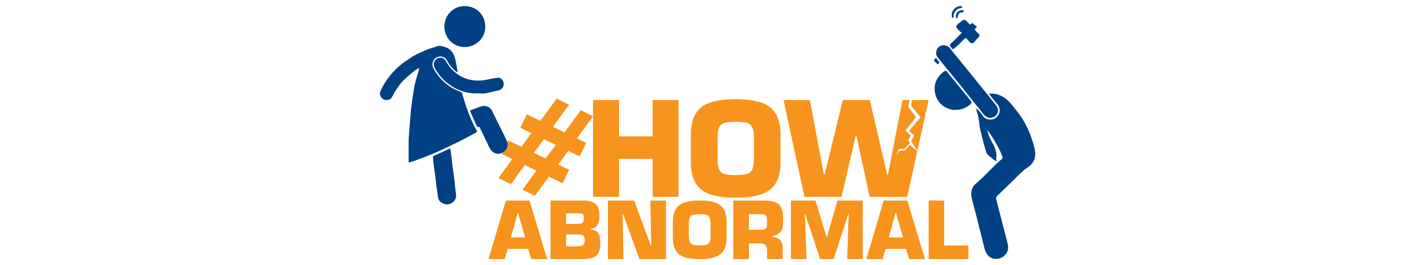
APPLICATION FORM
#HowAbnormal – Filmmaking Competition

Please fill in the form below to apply for the filmmaking competition #HowAbnormal on deconstructing gender stereotypes. After completing the form, send to howabnormal@gmail.com before midnight, January 1st, 2016 or to UNDP-MOFA Women’s Leadership Project at Room 201D, 30 Nguyen Du, Ha Noi before 17:00, December 31st, 2015.

(*) required
FOR INDIVIDUAL APPLICATION:
1. Full name (*):
2. Date of birth (dd/mm/yyyy) (*): 3. Gender: Male/Female/Other
4. Current address:
5. Telephone No. (*): 6. Email:
7. Profession (*):
8. Previous experience in film making? Yes/ No
If yes, please provide links to films:
9. State the reason you are interested to join the competition (*)

For under-18-year individual:
1. Full name of legal guardian (*):
2. Relation with the individual (*):
3. Current address (*):
4. Telephone No. (*): 5. Email:

FOR TEAM APPLICATION:
1. Team’s name (*):
2. Team leader’s full name (*)
2.1 Date of birth (dd/mm/yyyy) (*): 2.2 Gender: Male/Female/Other
2.3 Current address (*):
2.4 Telephone No. (*): 2.5 Email:
2.6 Profession (*):
3. Vice team leader’s full name (*)
3.1 Current address (*):
3.2 Telephone No. (*): 3.3 Email:
4. Number of team members (tentatively) (*):
5. State the reason you are interested to join the competition (*):

For under-18-year team leader:
1. Full name of legal guardian (*):
2. Relation with team leader (*):
3. Current address (*):
4. Telephone No. (*): 5. Email:

SCRIPT/STORYBOARD (*)
(Maximum length: 2.5 pages, maximum length of the film is 7 minutes)
1. Title:
2. Description of the Film Format (animation, comedy, sand-art,…):

By filling in and submitting the form to the organizers, I have read and understood the requirements of the competition. The information provided by me in this form is accurate and I am aware that false information will result in me being disqualified in this competition.

For inquiries, contact howabnormal@gmail.com or the hotline +84 4 3944 8527.

